BALLYMAHON MUNICIPAL DISTRICT

Corporate Affairs,
Aras an Chontae,
LONGFOIRT.

20th July 2017.

To: Each Member of Ballymahon Municipal District.

Dear Member,

You are requested to attend Meeting of Ballymahon Municipal District to be held in Ballymahon Community Library on Thursday, 27th July 2017 at 4.00 p.m. to transact business, as set out on the Agenda hereunder.

Yours sincerely,
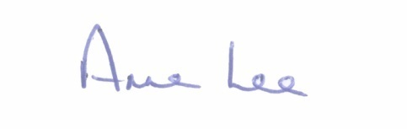

_______________
Anne Lee,
Meetings Administrator.

AGENDA

Prayer before meeting.

1. Confirmation of Minutes of Ballymahon Municipal District Meetings held on the 8th June and Annual Meeting held on the 19th June 2017 - copies enclosed.

2. Matters arising from Minutes.

3. Redevelopment of Lanesboro Substation - presentation by EirGrid Group

4. Management Report - enclosed.

5. Consideration of additional applications for funding under the Community Support Scheme.

6. Allocation of Funding under the Community Facilities Scheme 2017 – details enclosed.
7. Consideration of the Taking in Charge of the following housing estates -

- “Bracklin Park”, Edgeworthstown, Co. Longford.
- “Rath na gCarraige, Ballycloughan”, Co. Longford.
details enclosed.

8. Preparation of list of priority areas where footpath repairs are required.

9. Notices of Motions submitted by Councillors, as listed hereunder -

Councillor Gerard Farrell.

“I call on Longford County Council to replace the timber fence at the car park
at Rathcline Graveyard, as it is in bad repair.”

“That Ballymahon Municipal District provide funding support of €500 to
Lanesboro Drama Group on support of the new play for the Lough Ree
Monster Festival.”

10. Correspondence.

- Letter received from Marie Fallon, Principal, St. Mary’s N. S., Newtowncashel regarding the 50th Anniversary of the School
- Copy enclosed.

11. A.O.B.

